**Name:Attay Rasool**

**Roll no:p18-0046**

**Section:B**

Subject:Computer Network lab

Lab task 02

Question 01:

**Connect two end devices and forward the messeges**

Solution:

1. First connect two end devices with cross wire
2. Assign ip address both of end devices
3. Then go to simulation mode
4. Forwad the messege among pc1 to pc2
5. And check the status we show successful messege

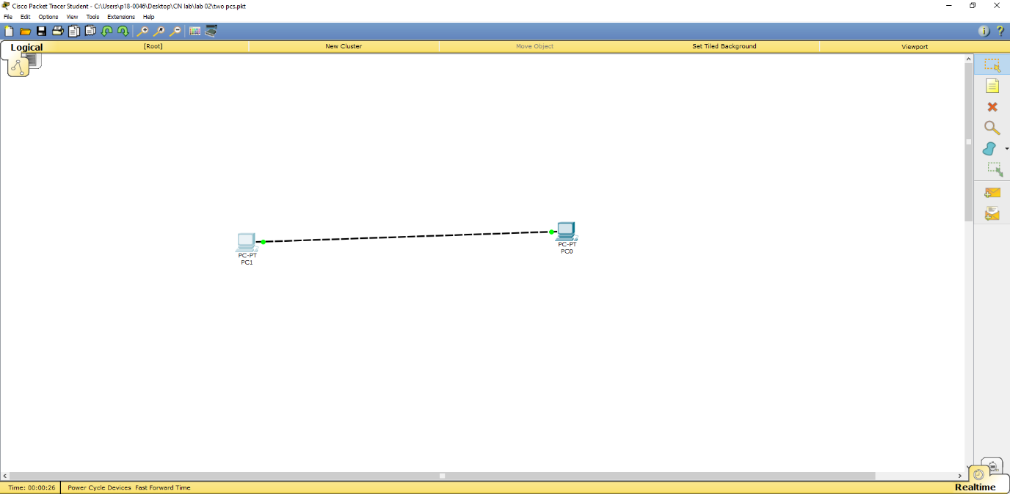

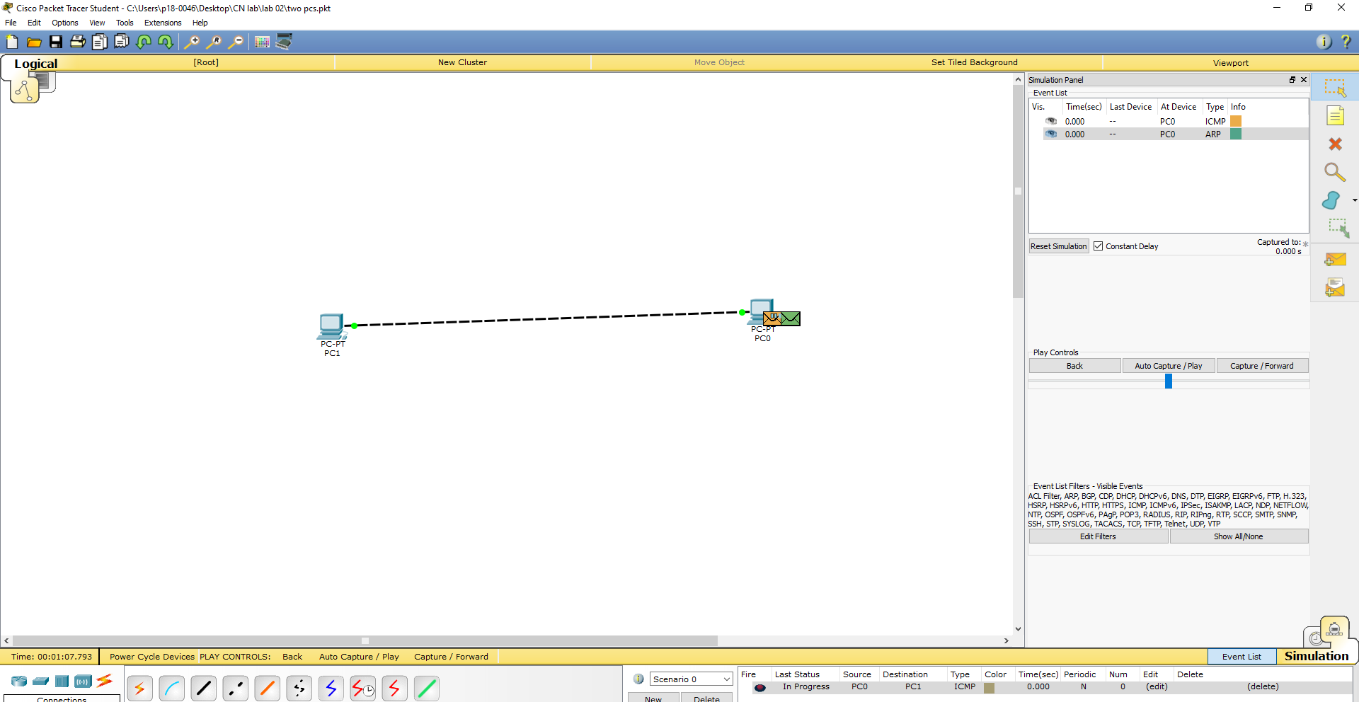

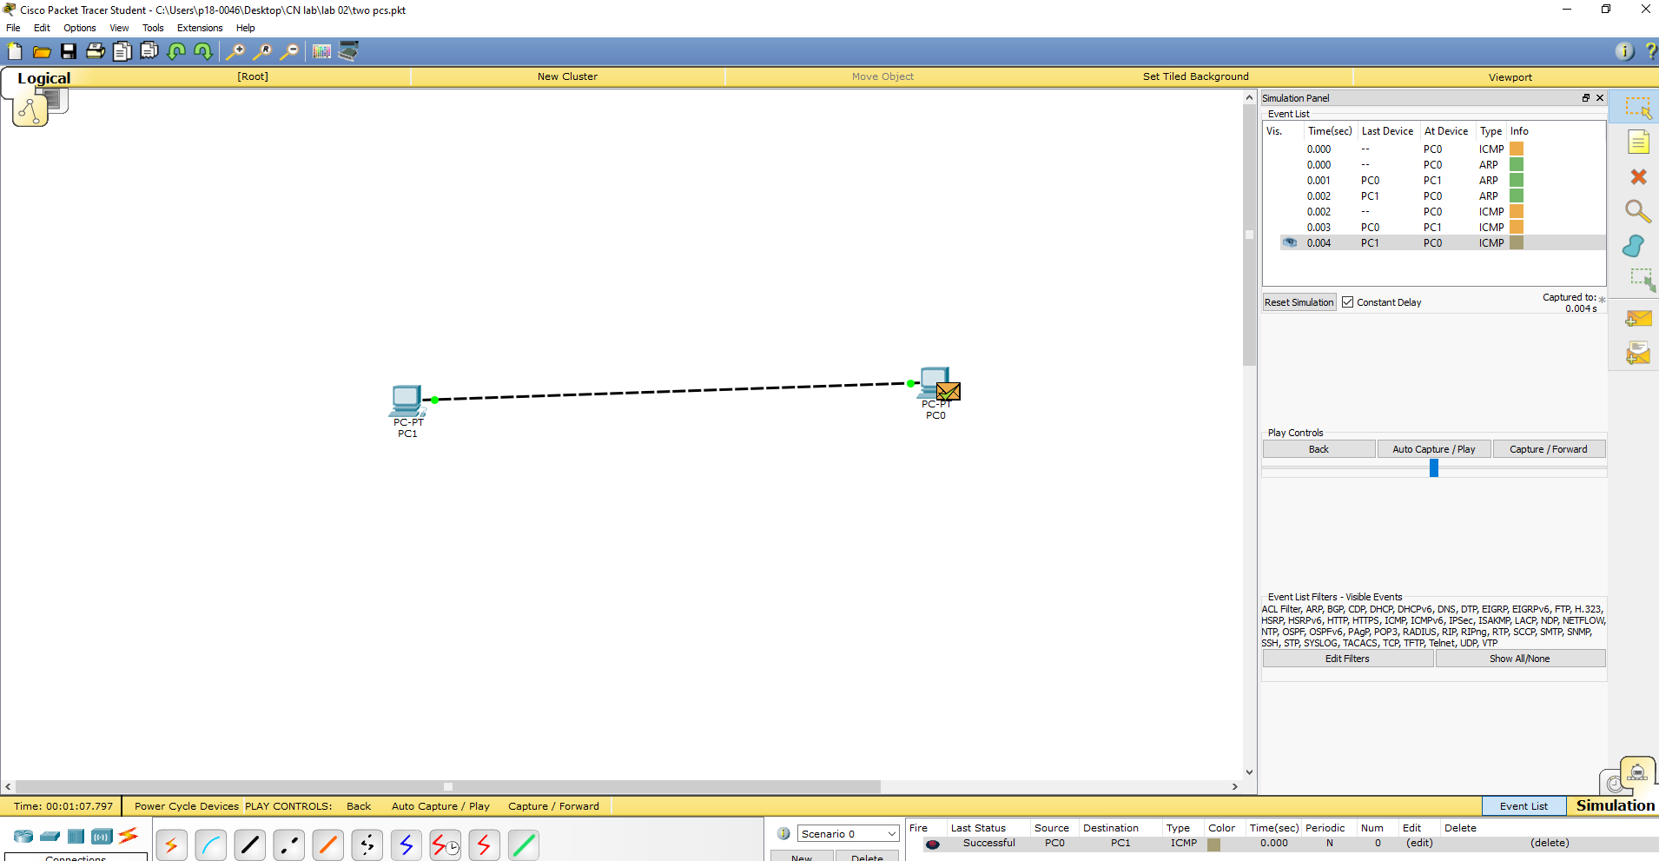

Q2:

Connect 4 end devices with the help of hub.

Solution:

When referring to a network, a hub is the most basic networking device that connects multiple computers or other network devices together.

Unlike a network switch or router, a network hub has no routing tables or intelligence on where to send information and broadcasts all network data across each connection.

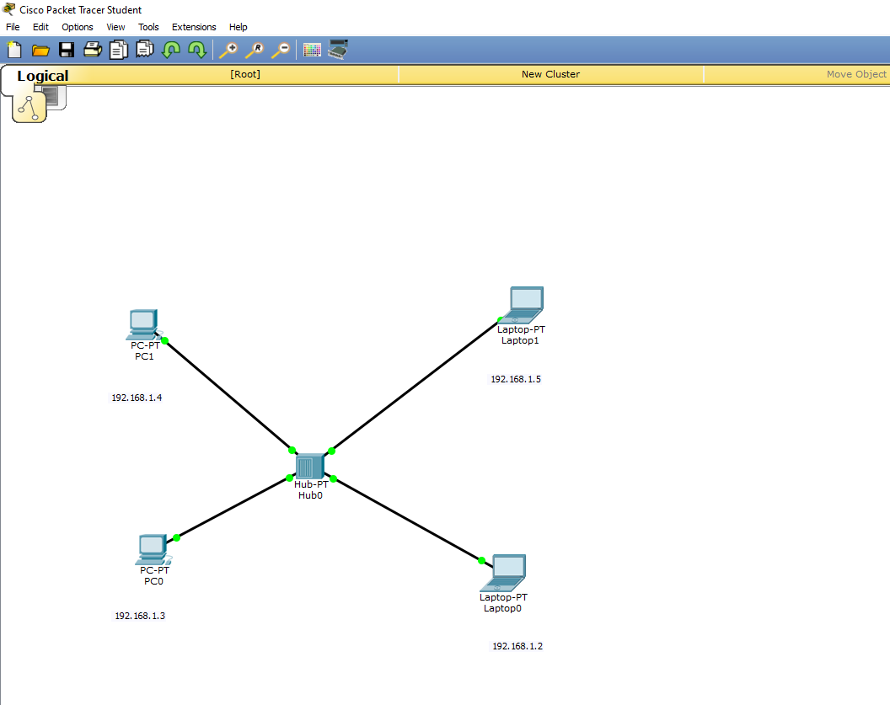

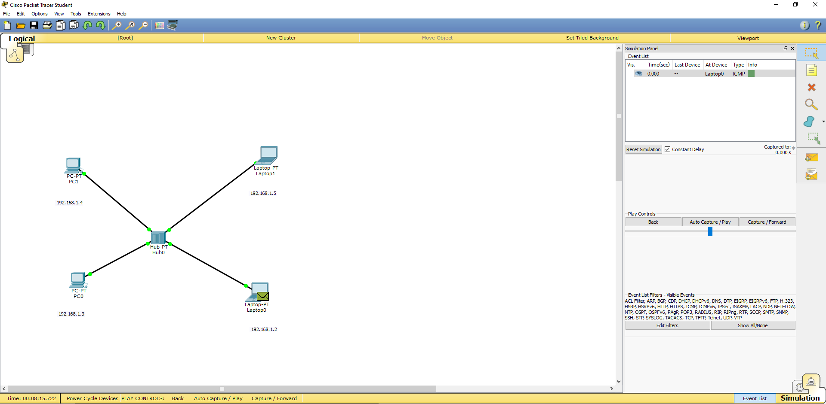

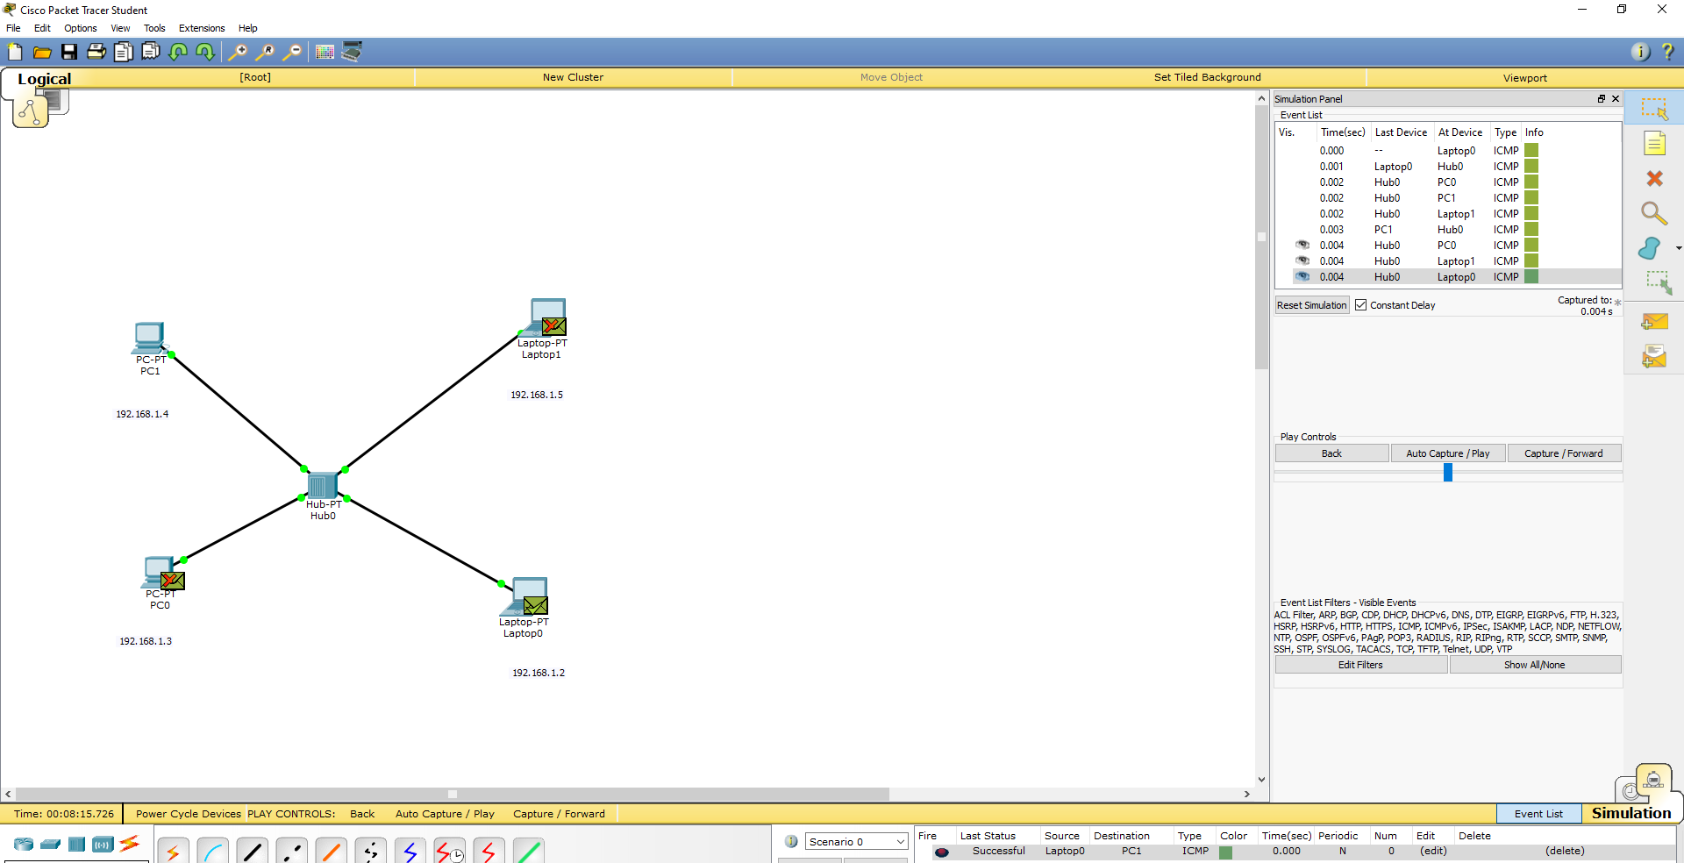

Q3:

Connect 4 end devices with the help of switch.

Solution:

On a network, a switch is a hardware device that filters and forwards packets through the network, but often not capable of much more.

A network switch is more advanced than a hub but not as advanced as a router.

